Password Cracking & Credential Attack Suite

Student Name : Sakshi Maruti Nalawade .
Institute : Unified Mentor
Lab Environment : Kali Linux

INDEX

 | Title
1. | Objective
2. | Tools
3. | Environment
4. | Methodology
5. | Results and Observations

Project Objectives

• Develop a dictionary generator for password testing.

• Extract password hashes from Linux shadow files and Windows SAM database (ethical environment only).

• Build a brute-force simulation engine to test password robustness.

• Analyse password strength based on complexity, entropy, and predictability.

• Generate a detailed audit report on password vulnerabilities and mitigation steps.

Tools & Technologies Used

Programming Languages:

• Python (recommended)

• Bash (optional)

Modules/Tools Used:

• hashlib (hashing operations)

• crypt / passlib (Linux password hash processing)

• reg.exe (Windows hive export)

• Samdump2 (hash extraction)

• John the Ripper / Hashcat (optional reference tools, not mandatory)

Documentation Tools:

• Word / Google Docs

• word (flowcharts and architecture diagrams)

Workflow / Architecture (Practical Explanation)

STEP 1 — Setup Lab Environment
Install required tools in Kali Linux
sudo apt update
sudo apt install john hashcat python3-pip
pip3 install passlib

sudo apt update
sudo apt install john hashcat python3-pip

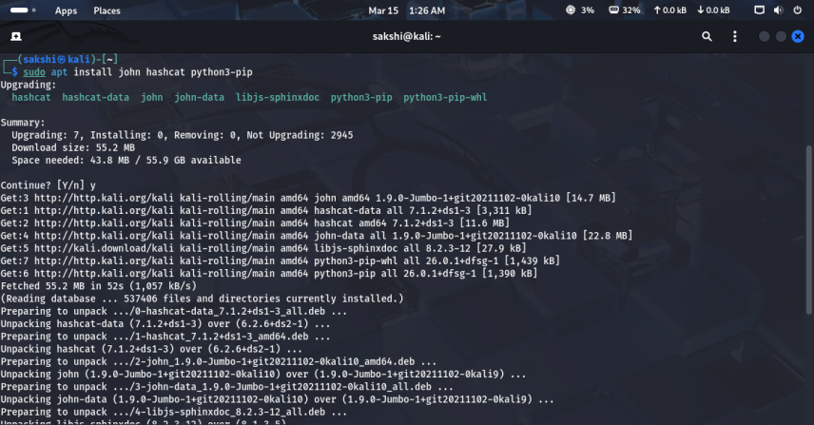
• Use the APT package manager (Recommended for system-wide installation): Check if passlib is available in the Kali Linux repositories and install it using apt, which is the preferred way to install system-wide Python packages.
sudo apt update
sudo apt install python3-passlib

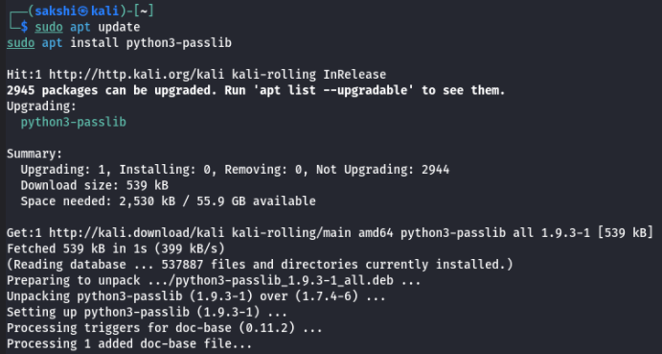
• Use a Python virtual environment (Recommended for project-specific use): This is the safest method to install non-Kali-packaged Python libraries, as it isolates the installation from the system's Python environment.
sudo apt install python3-venv

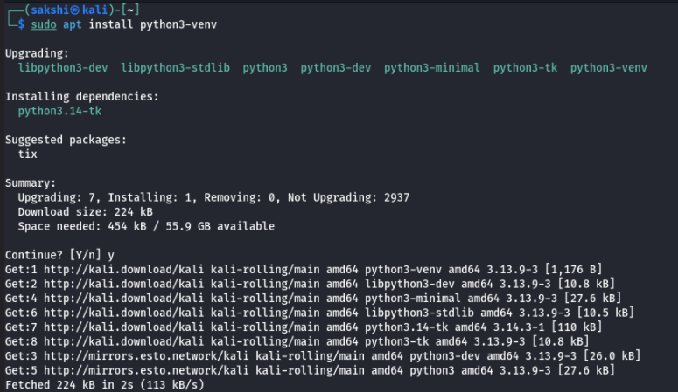

• Create a virtual environment in your project directory (replace venvname with a name of your choice):
python3 -m venv venvname

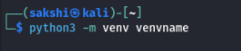

• Activate the virtual environment:
source venvname/bin/activate

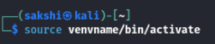

• Install passlib using pip within the activated environment:
pip install passlib

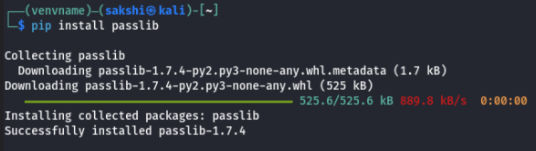

STEP 2 — Dictionary Generator
• Create a Python script to generate password wordlists.

File: dictionary_generator.py

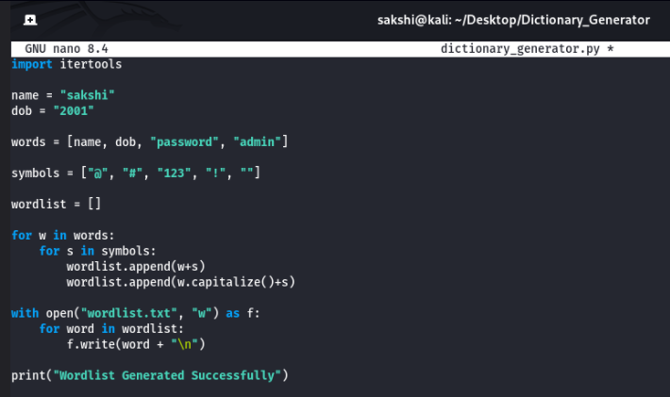

Run Script
python3 dictionary_generator.py

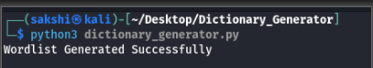

Generated Wordlist Example

cat wordlist.txt
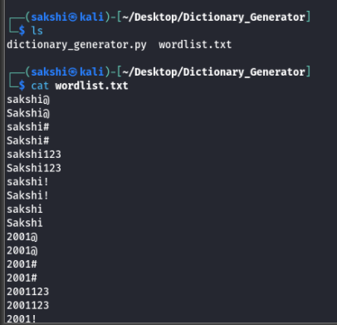

STEP 3 — Hash Extraction (Linux Shadow)
• Linux stores password hashes in:
/etc/shadow

• Gain Root Access: Elevate privileges to read restricted files.
sudo –s

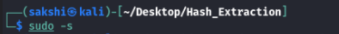

• Copy Necessary Files: Create a backup of passwd and shadow in your current directory.
cp /etc/passwd .
cp /etc/shadow .

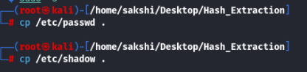
• Combine Hashes (Unshadow): Use the unshadow utility (part of John the Ripper) to combine the files, creating a format recognized by password crackers.
unshadow passwd shadow > myhashes.txt

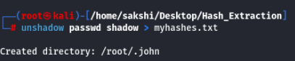

• Verify Extraction: Display the extracted hashes.
cat myhashes.txt

Explanation:
$6 = SHA512
$5 = SHA256
$1 = MD5

STEP 4 — Extract Windows SAM Hashes (Offline)
From Windows system export registry: SAM, SYSTEM

Command:
• Displays all user accounts on the computer: Use the net user command is a Windows command used to view and manage user accounts, including creating, modifying, and deleting users.
net user
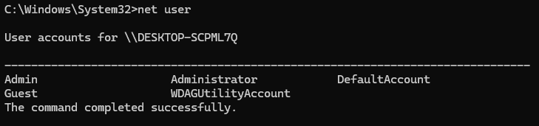
• Shows details of the Administrator account: This is used to view or manage the built-in Administrator account in Windows.
net user Administrator
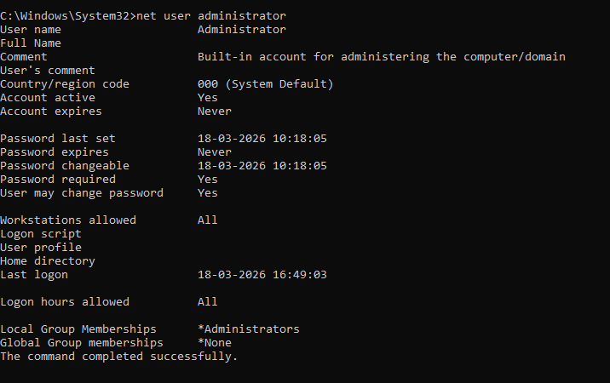
To check Windows registry files: SAM, SYSTEM and SECURITY.
• In Windows usually refers to the system configuration folder that stores registry files like SAM and SYSTEM.
config
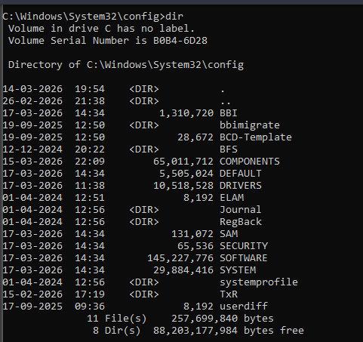
Save (export) the registry hive into a file named : sam.save and system.save .
• sam.save: is used to export the SAM registry hive containing user password hashes for offline analysis.
reg save HKLM\SAM sam.save

• system.save: exports the SYSTEM registry hive, which contains keys required to decrypt password hashes from the SAM hive.
reg save HKLM\SYSTEM system.save

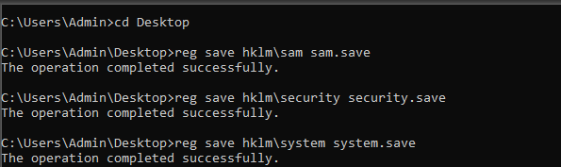

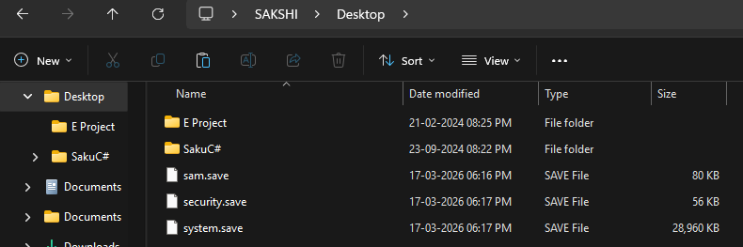

Copy files to Kali.
Send files as is to Kali Linux on Windows.

• File inside Information: Displays the contents of the SAM file, but since it is a binary registry hive, the output is not readable.
cat sam.save
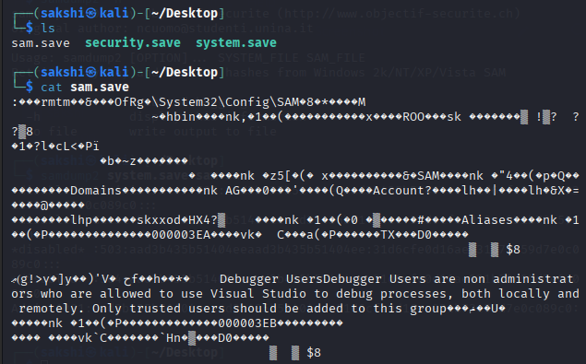

samdump2 Tool : is a tool used in Kali Linux to extract Windows user password hashes from the SAM and SYSTEM files.
• To Displays usernames: Extracts Windows password hashes from SAM & SYSTEM files
samdump2 system.save sam.save

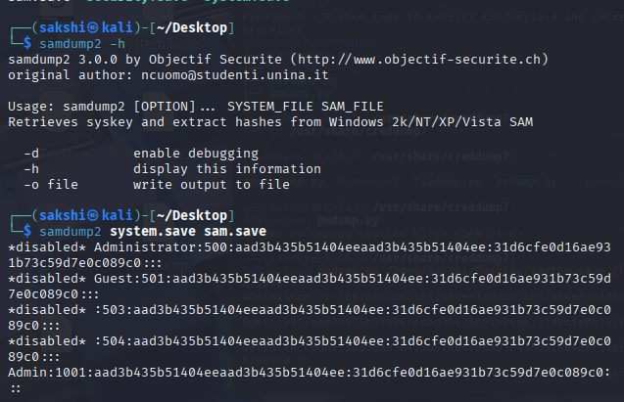

• Extracts password hashes and saves them into windowsCredump file.
Samdump2 system.save sam.save > windowsCredump
• Shows stored credential/hash data from the windowsCredump file.
cat windowsCredump

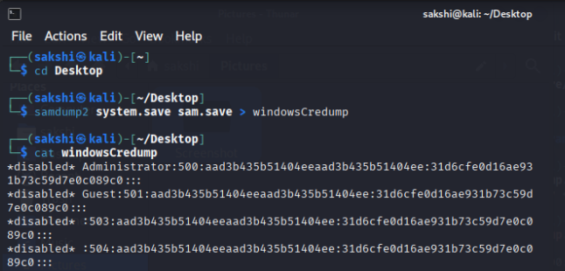
Creddump7 Tool: creddump7 is a tool used to extract Windows credentials and password hashes from offline registry files.
• Executes pwdump script to dump Windows user password hashes.
Python pwdump.py

• Combines SYSTEM + SAM files to decrypt and display Windows user password hashes (NTLM)
python pwdump.py /home/sakshi/Desktop/system.save /home/sakshi/Desktop/sam.save

• Extracts password hashes and saves them into windump file.
python pwdump.py /home/sakshi/Desktop/system.save /home/sakshi/Desktop/sam.save > windump

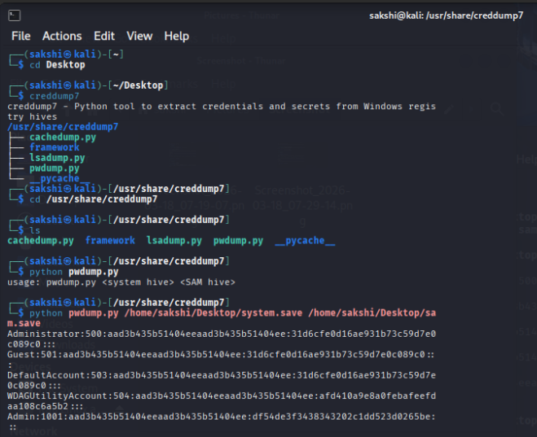

• Shows stored credential/hash data from the windump file.
cat windump

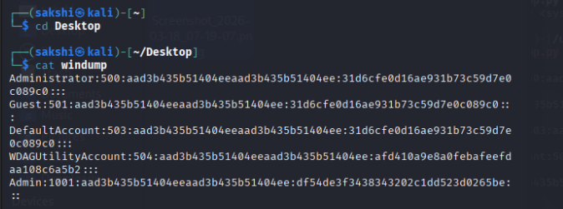

hashcat Tool: is a powerful tool used to crack password hashes using GPU/CPU.

• Takes hash values (like NTLM, MD5, and SHA)
• Uses attacks like:
- Dictionary attack
- Brute-force attack
- Rule-based attack

• Displays detailed list of all files (including hidden) in the current directory.
ls -la

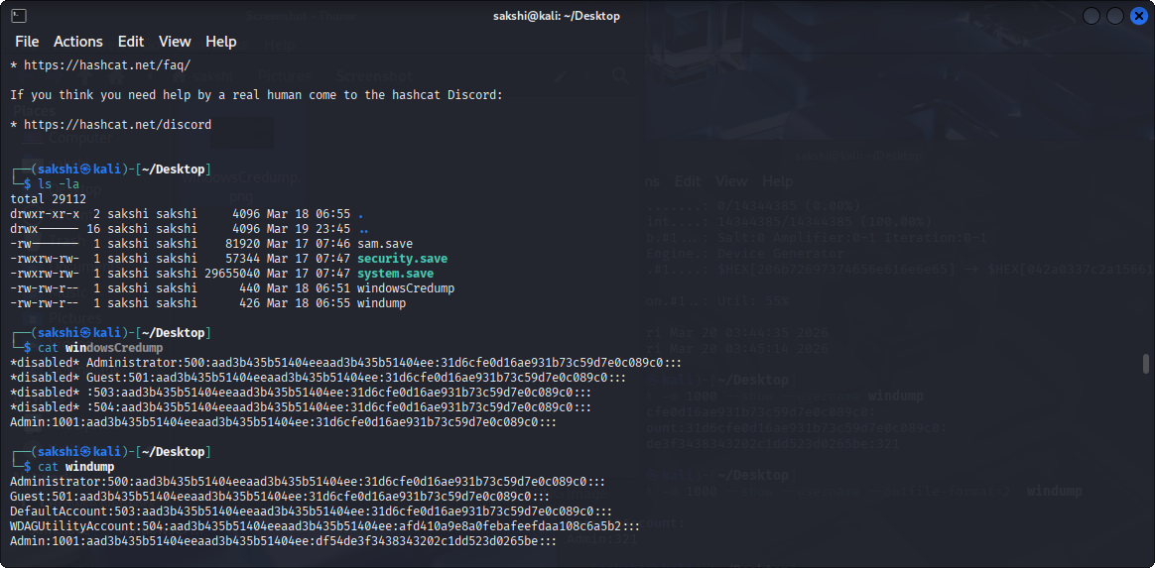

• Uses a dictionary attack to crack NTLM password hashes from the windowsCredump file using the rockyou wordlist.

hashcat –a 0 –m 1000 windowsCredump /usr/share/wordlist/rockyou.txt

• hashcat → password cracking tool
• -a 0 → dictionary attack
• -m 1000 → NTLM hash type
• windowsCredump → file containing hashes
• /usr/share/wordlists/rockyou.txt → wordlist used to guess passwords

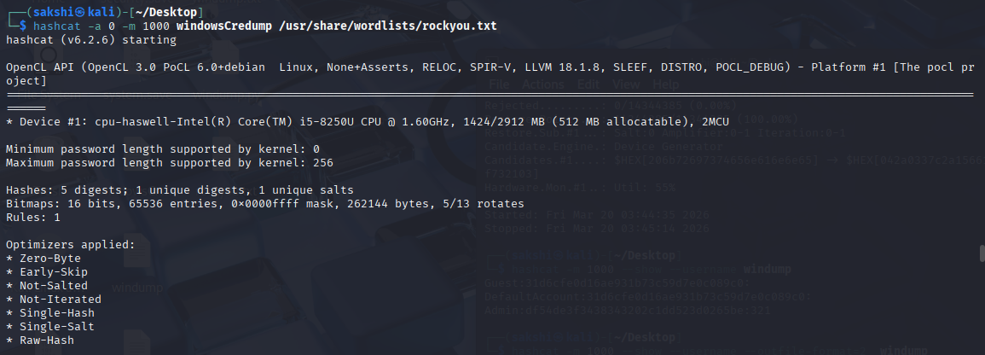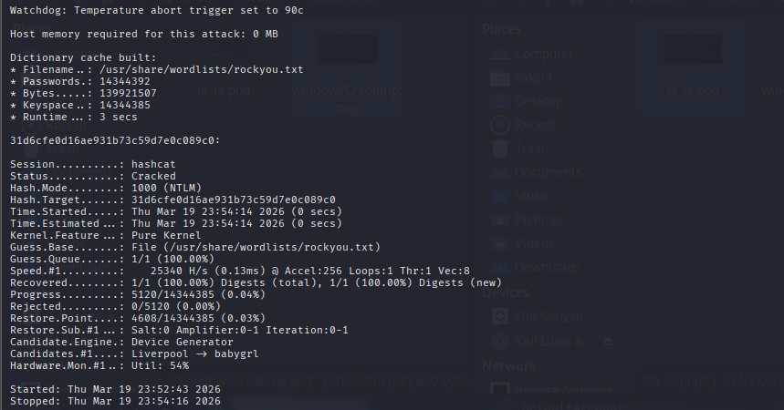

• Loads NTLM hashes (with usernames) from the file for cracking
hashcat –m 1000 –username windowsCredump
• --username → tells hashcat the file contains username:hash format

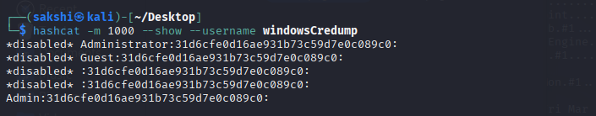

• Uses a dictionary attack to crack NTLM password hashes from the winddump file using the rockyou wordlist.
hashcat –a 0 –m 1000 windump /usr/share/wordlist/rockyou.txt

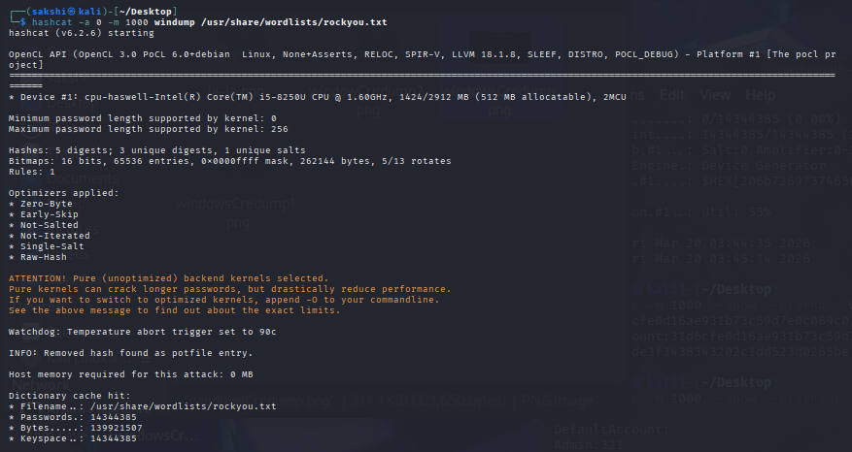
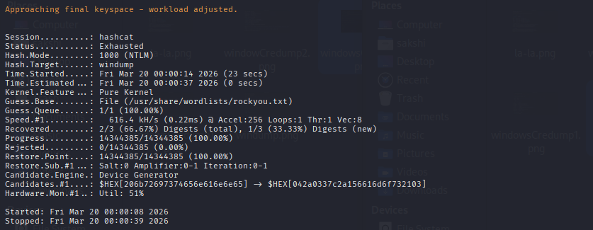

• Loads NTLM hashes (with usernames) from the file for cracking
hashcat –m 1000 –username windump

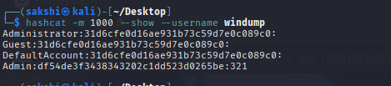

STEP 5 — Dictionary Attack Simulation
Use John the Ripper.
Command:
john –format=NT --wordlist=wordlist.txt windump

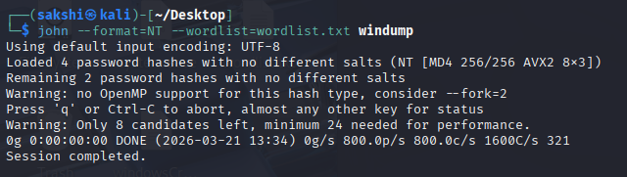
Check cracked passwords:
john --show –format=NT windump

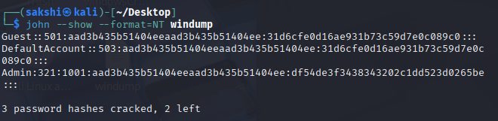

STEP 6 — Password Strength Analyser
Create Python script.
File: password_strength.py

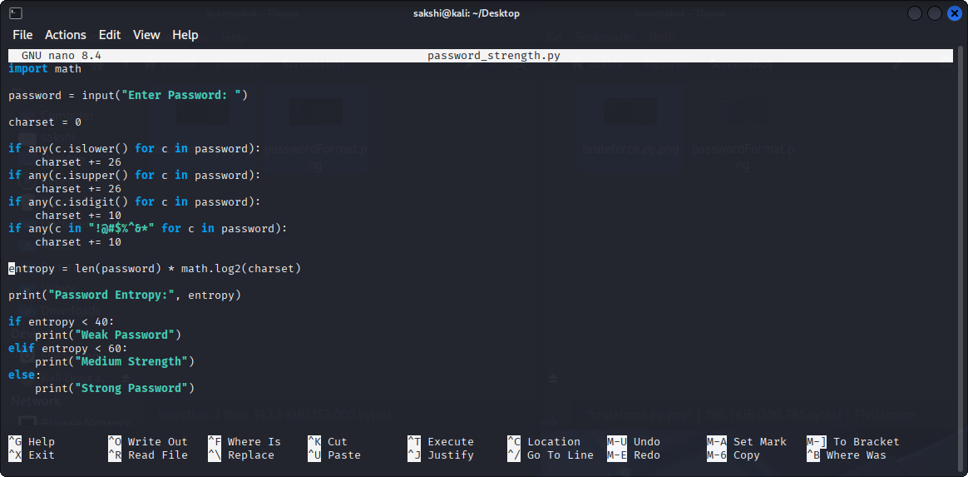

To check password pattern
Python3 password_strength.py
Run this command and then enter the password:___________
To get password information such as password Entropy and password type.

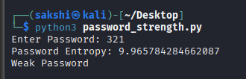

STEP 7 — Generate Security Audit Report

Report Generation

After performing password cracking and analysis, a detailed report is generated to summarize findings, risks, and recommendations.

1 Identified Weak Passwords

The system lists all passwords that were successfully cracked during the attack simulation.

Examples:

* 321

* admin123

* password

* user@123

These passwords are considered weak due to their simplicity and predictability.

2 Cracking Time Analysis

The time required to crack each password is recorded to evaluate its strength.

Password | Attack Type | Time Taken
321 | Dictionary Attack | 1 second
admin123 | Dictionary Attack | 2–5 seconds
Sakshi@123 | Brute Force | Few minutes
Xy#9Lp!Q2$ | Brute Force | Not cracked

This shows that simpler passwords are cracked much faster than complex ones.

6.3 Risk Assessment

Based on the results, the following risks are identified:

* Weak passwords can be cracked instantly.

* Reused passwords increase vulnerability.

* Predictable patterns (names, dates) are easy targets.

* Systems without password policies are at high risk.

6.4 Mitigation Strategies

To improve security, the following measures are recommended:

* Use strong passwords (minimum 8–12 characters).

* Include uppercase, lowercase, numbers, and symbols.

* Avoid common words and personal information.

* Implement account lockout mechanisms.

* Enable multi-factor authentication (MFA).

* Regularly update passwords.

6.5 Summary

The report highlights that password strength directly impacts system security. Strong and complex passwords significantly reduce the chances of successful attacks.

Proper awareness and security practices can prevent most credential-based attacks.

Final Project Architecture

User Input

Dictionary Generator

Hash Extraction

Dictionary / Brute Force Simulation

Password Strength Analyser

Security Audit Report
End

Learning Outcome

This project enables understanding of:

• How passwords are stored, hashed, and protected

• Ethical password cracking methodologies

• Authentication security auditing

• Red team vs blue team password assessment techniques

• Best practices for secure password creation and enforcement
• Defensive password policies

